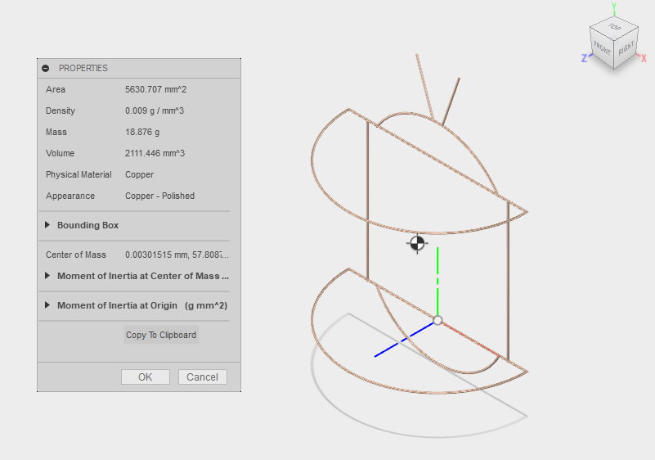

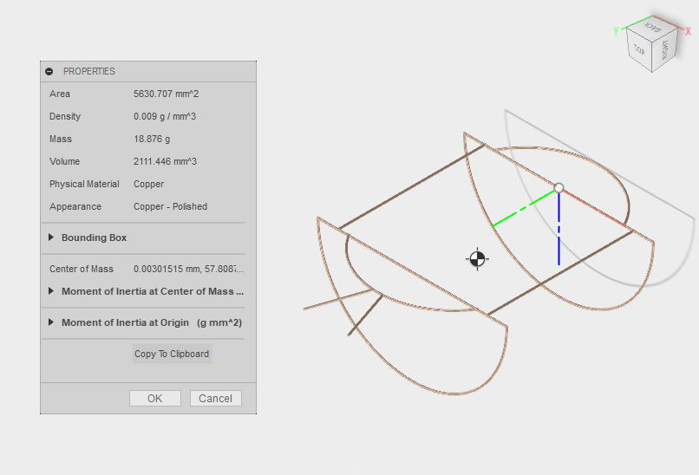

Area 5630.707 mm^2

Density 0.009 g / mm^3

Mass 18.876 g

Volume 2111.446 mm^3

Physical Material Copper

Appearance Copper - Polished

Bounding Box

Length 136.06 mm

Width 195.531 mm

Height 68.848 mm

Center of Mass 0.00301515 mm, 57.8087 mm, 15.1494 mm